**Power BI**

**Assignment – 3**

**Q1• Use the Employee Details dataset and perform the following activities: -**

− Split the column CITY and separate the code associate with each city like - Allahabad[AL2] should be only Allahabad and [A2] will be separate.

A – Employee Details Data sheet has been loaded successfully and performed the step Split the Column CITY and separate the code associate with each city. Please find the below image for your reference.

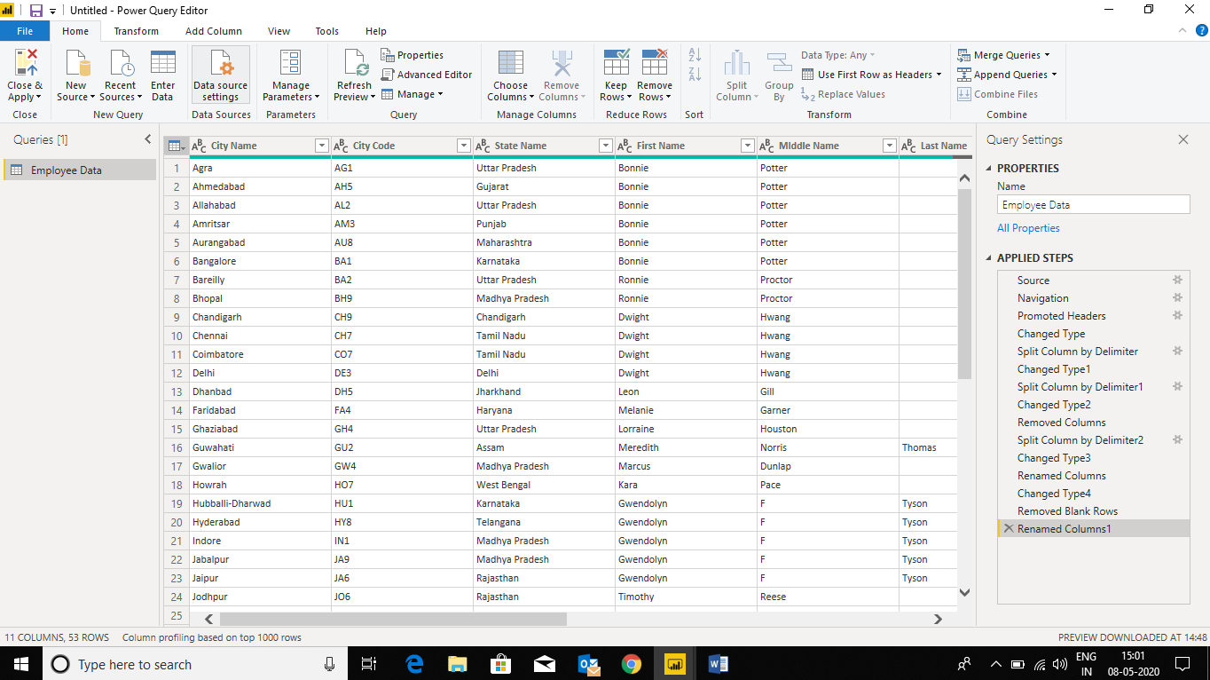

**Q2 − Extract the first name from EMPLOYEE NAME column and transform the column.**



**Q3− Using the JOINING DATE column extract the Year and no. of days for that month.**

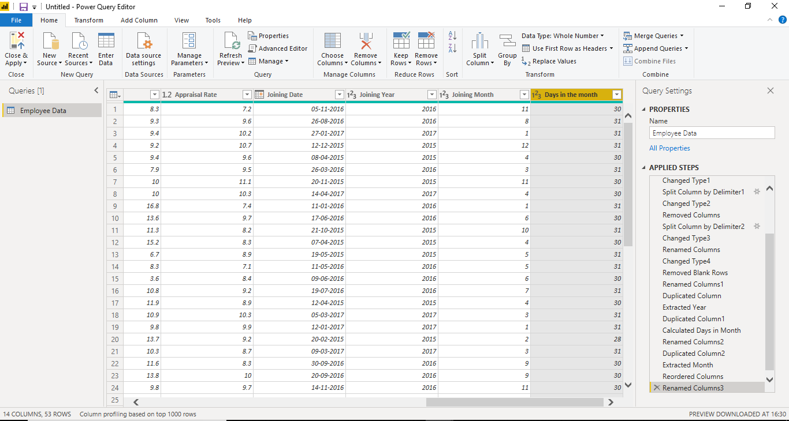

**Q4− Create a visual of your choice and show the how much salary has been paid to each state and which state has lowest pay-outs**.

A – As per my choice, have considered column chart to project the visualizations for **salary vs State** from the employee data sheet and as per the understanding **Assam and Chandigarh** as the lowest pay-outs states.

